Image-derived MTF method and MTF compensation for
CBERS-02B WFI imager

LI Xiaoying^{1, 2}, GU Xingfa^{1, 2}, YU Tao^{1, 2}, CHENG Tianhai^{1, 2}, GAO Hailiang^{1, 2},
LI Jiaguo^{1, 2}, YANG Xiaofeng^{1, 2}
1. State Key Laboratory of Remote Sensing Science, Jointly Sponsored by the Institute of Remote Sensing Applications of Chinese Academy of Sciences and Beijing Normal University, Beijing 100101, China;
2. Demonstration Centre for Spaceborne Remote Sensing National Space Administration, Beijing 100101, China
Abstract: In this paper, a method to evaluate the in-flight MTF (Modulate Transfer Function) of the WFI (Wide Field Imager) on CBERS-02B is presented and the WFI images are restored. The CCD is another payload on CBERS-02B with high spatial resolution. Using the CCD images as high resolution images, the two-image comparison approach is applied to determine the MTF of the WFI with a pair of images acquired over Beijing on Nov. 10, 2007. As the results, MTF values in three directions are derived. The MTF values at Nyquist frequency in cross-track, in-track and 45° directions were respectively about 0.43, 0.52 and 0.35 for red band and 0.30, 0.46 and 0.36 for near-infrared band. Image-derived MTF values are applied to calculate the half bandwidths of the WFI. The results indicate that the instant fields of view of the WFI in the cross-track, in-track and 45º-track directions were respectively 1.188 pixels, 1.165 pixels and 1.281 pixels for red band, and respectively 1.258 pixels, 1.195 pixels and 1.326 pixels for near-infrared band. Weiner filter model is used to perform the MTF compensation for WFI images. The results show that the restored image seemed clearer and contained more detailed information.
Key words: CBERS-02B, CCD, MTF, the two-image comparison approach
CLC number: （请查询分类代码） Document code: A

1 INTRODUCTION
The MTF is a fundamental imaging system design specification and system quality metric often used in remote sensing. The MTF is acquired by performing FFT (fast fourier transform) on PSF (point spread function) and normalizing its modulation. It results from the cumulative effects of the instrumental optics (diffraction, aberrations, focusing error), integration on a photosensitive surface, charge diffusion along the array and image motion induced by the movement of the satellite during imaging (Leger ,et al., 2003) . The MTF can be tested accurately in the lab, but it will change due to the refocus of the sensor and the MTF of the atmosphere. Thus, in-flight MTF determining and compensation is a vital step for the comprehensive applications of WFI images.
…The spectral band response functions of two corresponding spectral bands of CCD and WFI were similar, which were shown in Fig.1 and Table 1….

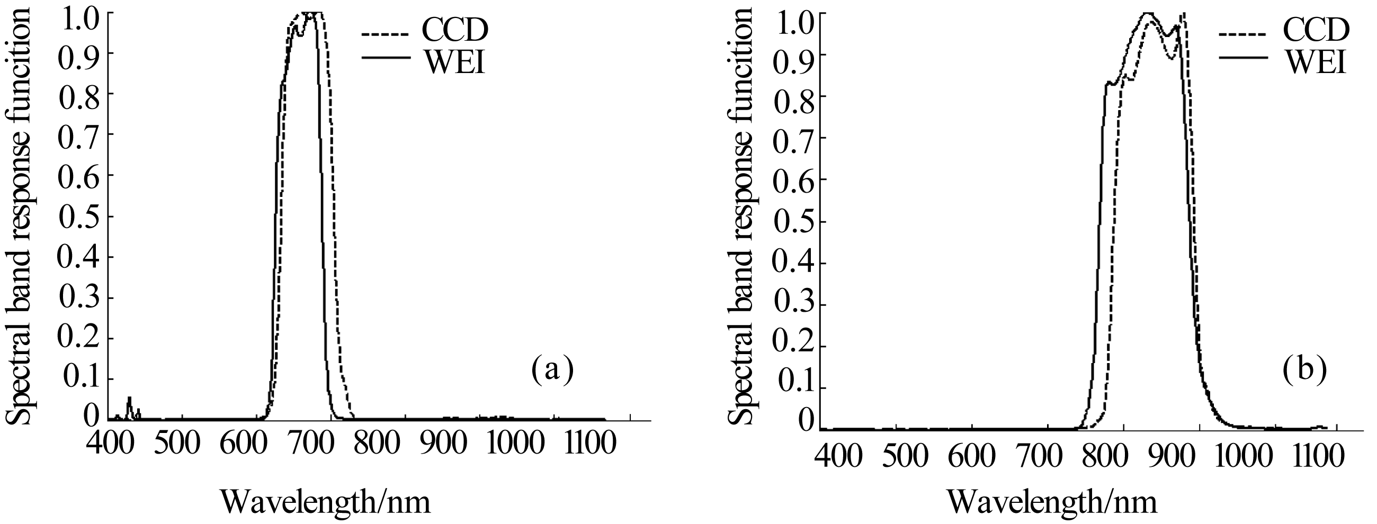
- Red band; (b) Near-infrared band

Fig. 1 Spectral band response functions of CCD and WFI

Table 1 The red and near-infrared bands of CCD and WFI
CCD bands | CCD /nm | Centre wavelength /nm | Spatial resolution /m | WFI bands | WFI /nm | Centre wavelength /nm | Spatial resolution /m
3 | 630—690 | 671.96 | 19.5 | 1 | 630—690 | 657.74 | 258
4 | 770—890 | 843.1 | 19.5 | 2 | 770—890 | 831.98 | 258

…

Acknowledgements: The CCD and WFI images were kindly offered by China Centre for Resource Satellite Data & Application.

REFERENCES
Bretschneider T, Bones P J, McNeill S and Pairman D 2001. Image-based quality assessment of SPOT data. Proceedings of the American Society for Photogrammetry & Remote Sensing, St. Louis, April, 2001
Du H and Voss K J. Effects of point-spread function on calibration and radiometric accuracy of CCD camera. Applied Optics, 43 (3): 665-670
Fonseca L M G, Prasad G S S D and Mascarenhas N D A 1993. Combined interpolation—restoration of Landsat images through FIR filter design techniques. International Journal of Remote Sensing, 14 (13): 2547-2561

附1： “著者-出版年”体系
1 文中标注原则：
参考文献在文中只需列出作者姓氏以及出版年。
如果作者姓氏已经在正文中出现，则括号中只写出版年，如：In a recent study Dunham (1997) argued that …；
如果作者姓没有在正文中出现，则在括号中列出，如A recent study (Dunham, 1998) shows that…；
如果引用同一作者在不同年份出版的多篇论文，括号中按出版年顺序列举，如 Some studies (Dunham, 1996, 1998, 2005; Smith, 2002) show that…；
引用同一作者在同一年出版的多篇论文，在括号内的出版年后加字母a, b, c，如：Johnson (1996a) discussed that …;
如果有多篇文献作者姓氏相同，则需加列名的首字母以区分，如： The most recent work (Wang G L, 2007; Wang W M, 2007) has shown that…;
如果文献的作者有2位，则两位作者的姓氏都列出，如Matthews and Jones (1998) have proposed that…，又如the most recent work (Matthews & Jones, 1998) has shown that; 如果文献的作者有3位及以上，只列第一位作者加 ,et al.，如：Wilson ,et al. (1993) 。

2 文后参考文献列表 （按首字母顺序排列）
2.1 标题大小写问题：
论文标题只有第一个单词首字母大写，其他单词首字母小写。书名，期刊名，学位论文标题，报告集，会议集标题等所有实词首字母都大写。
2.2作者：
请提供全部作者姓名。姓前名后，姓全拼，名只写首字母并大写，名后不加“.”，作者之间用“,”，作者和出版年间用“.”。最后一个作者前加“and”。
Qin W H, Gerstl S A and Deering D W. 2002. Characterizing leaf geometry for grass and crop canopies from hotspot observations: A simulation study. Remote Sensing of Envronment, 80(2):100-113
2.3 文献类别
（1）专著：
作者. 出版年. 书名. 出版地（指出版社所在城市）：出版社：页码
Kang Y H. 1996. Data Fusion: Theory and Application. Beijing: Science Press,18-22
（2）期刊：
作者. 出版年. 论文标题. 期刊名，卷（期）：页码
说明：论文标题只有第一个单词首字母大写，其他单词首字母小写。期刊名所有实词首字母都大写。
Xu X B, Jiao J and Meng Y. 2004. The model of plant transform efficiently on Songnen Plain. System Sciences and Comprehensive Studies in Agriculture, 20(4): 306-308
（3）会议论文：
作者. 出版年. 论文标题. 会议论文名或者文集名. 出版地：出版社：页码
说明：论文标题只有第一个单词首字母大写，其他单词首字母小写。期刊名所有实词首字母都大写。
Jiang Q G, Fang H B, and Li Y H. 1997. Research on spatio-temporal change of lakes and its geological mechanism in Qinghai-Tibet Plateau base on remote sensing technology. Collection of Thesis of the 16th National Remote Sensing Technology Seminar. Beijing：Geological Publishing Press：1-5
（4）报告：
作者. 出版年. 报告标题. 报告号. 城市：报告单位或者出版社
Katerina P P and Warren B P. 2003. An Adamptive Dynamic Programming Algorithm for a Stochastic Multiproduct Batch Dispatch Problem. Princeton University
（5）学位论文：
作者. 出版年. 论文标题. 城市：单位，页码
Shao Y. 2000. Studies on Rice Backscatter Signatures in Time Domain and its Application. Beijing: Chinese Academy of Sciences, 22-38
（6）专利：
专利责任人. 出版年. 专利名称. 专利国别，专利号
Smith J. 1985. Optomechanical two-bar lens . U.S., No. 3,333,999
（7）网上参考文献：
作者.刊登年或者最后一次更新的年. 标题[文献类型标识]. 出版社（有则写）.期刊名(有则写), 页码[引用日期]. 网址
CHRISTINE M. 1998. Plant physiology in the Genome Era[J/OL] . Science, 281：331-332 [1998-09-23]. http://www.sciencemag. org/ cgi/collection/anatmorp
其中，引用型参考文献必须注明引用页码（阅读型和推荐型可不写）；凡有卷期号的文献需查询完整，每年为一卷的可以省略卷号。

附2：补充说明

（1）题目、摘要与关键词：
1.题目尽量简短，关键词尽可能多地体现在题目中；
2.报道性摘要要写明目的、方法、结果和结论,研究背景、意义等放到引言中介绍，使用最简洁的语言高度概括文章主要内容；
3.关键词不要太宽泛，“遥感”、“图像”等词最好不要出现；请提供5-8个关键词。
（2）公式中符号、字母格式：
变量用斜体；两个以上变量字母并列用斜体；矩阵、矢量、向量和集合用黑斜体, R(实数集)，Z(整数集)， N(自然数集)用正黑体, 且各变量要求加以说明.标准函数用正体, 上下标需要标注清楚，要与相乘的量区分清楚。

